VISVESVARAYA TECHNOLOGICAL UNIVERSITY
“JNANA SANGAMA”, BELAGAVI-590018.
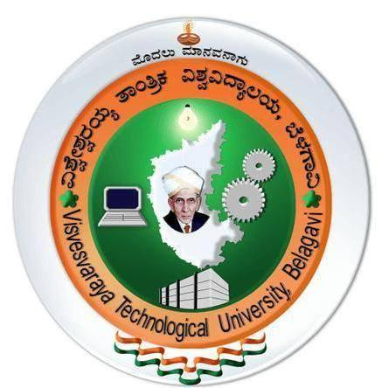
A
Seminar Report
on

“DETECTION SYSTEM IN ANDROID”

SUBMITTED TO THE REQUIREMENT OF 8th SEMESTER SEMINAR OF
BACHELOR OF ENGINEERING
IN

COMPUTER SCIENCE AND ENGINEERING

By

GAURAV SHARMA [1JB15CS051]

UNDER THE GUIDANCE OF
Mrs. NIRMALA H
Associate Professor
Dept of CSE, SJBIT

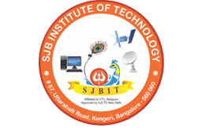

DEPARTMENT OF COMPUTER SCIENCE AND ENGINEERING

SJB INSTITUTE OF TECHNOLOGY

No. 67, BGS Health & Education City, Dr. Vishnuvardhan Road

Kengeri, Bengaluru- 560060
2018 - 2019
||Jai Sri Gurudev||
Sri Adichunchanagiri Shikshana Trust ®

SJB INSTITUTE OF TECHNOLOGY

BGS Health & Education City, Kengeri, Bangalore-560060.

DEPARTMENT OF COMPUTER SCIENCE AND ENGINEERING

CERTIFICATE

Certified that the Technical Seminar entitled “Detection System in Android” carried out by Gaurav Sharma bearing the USN 1JB15CS051 respectively is the bonafide student of SJB Institute of Technology in partial fulfillment for the award of BACHELOR OF ENGINEERING in Computer Science and Engineering of the Visvesvaraya Technological University, Belagavi during the academic year 2018-19. It is certified that all corrections/suggestions indicated for Internal Assessment have been in the Report deposited in the Departmental library. The report has been approved as it satisfies the academic requirements in the respect of Seminar as prescribed for the said degree.

___________________
Signature of the Guide
Mrs. Nirmala H
Associate Professor
Dept. of CSE, SJBIT

___________________
Signature of the HOD
Dr. KRISHNA A N
Professor& Head
Dept. of CSE, SJBIT

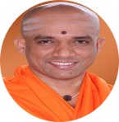
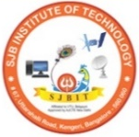
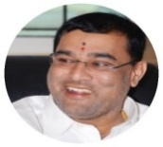
ACKNOWLEDGEMENT

I would like to express my profound gratefulness to His Divine Soul Jagadguru Padmabhushan Sri Sri Sri Dr. Balagangadharanatha Mahaswamiji and His Holiness Jagadguru Sri Sri Sri Dr. Nirmalanandanatha Mahaswamiji for providing us an opportunity to study in this esteemed institution.

I would also like to express my profound thanks to Revered Sri Sri Dr. Prakashnath Swamiji, Managing Director, SJB Institute of Technology, for his continuous support in providing amenities to carry out this Seminar in this admired institution.

I express my gratitude to Dr. Puttaraju, Principal, SJB Institute of Technology, for providing me an excellent facilities and academic ambience; which has helped me in satisfactory completion of Seminar work.

I extend my sincere thanks to Dr. Krishna A N, Professor and Head of the Department Computer Science and Engineering, for providing me valuable support throughout the period of my Seminar work.

I wish to express my heartfelt gratitude to my guide Mrs. Nirmala H, Associate Professor, for her valuable guidance, suggestions and cheerful encouragement during the entire period of my Seminar work. I also thank Technical Seminar Coordinator, Mrs. Pavithra G S, Associate Professor who has extended her support to carry out my Seminar fruitfully.

Finally, I take this opportunity to extend my earnest gratitude and respect to my parents, teaching & non-teaching staffs of the department, the library staff and all my friends, who have directly or indirectly supported me during the period of my Seminar work.
Regards,
Gaurav Sharma (1JB15CS051)

